**Computer Networks Lab 2**

**Name: Vaibhav Chaudhari**

**ID: 2017B5A70834G**

**Find network commands to do the following.**

1. **See the statistics of TCP and UDP ports on Linux machine**

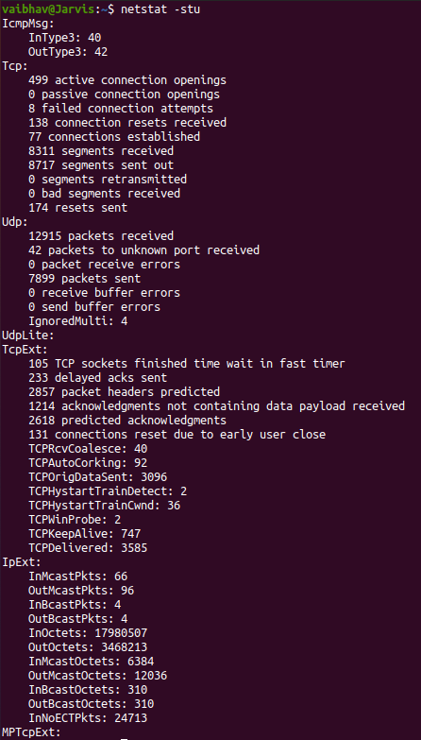

**netstat** is used to display network related information like network connections, routing tables, interface statistics, masquerade connections, multicast memberships etc.

To view the Network statistics we can use the **-s** flag along with **-u** flag for all UDP ports and **-t** flag for all TCP ports.

1. **Enlist the listening ports on your machine**

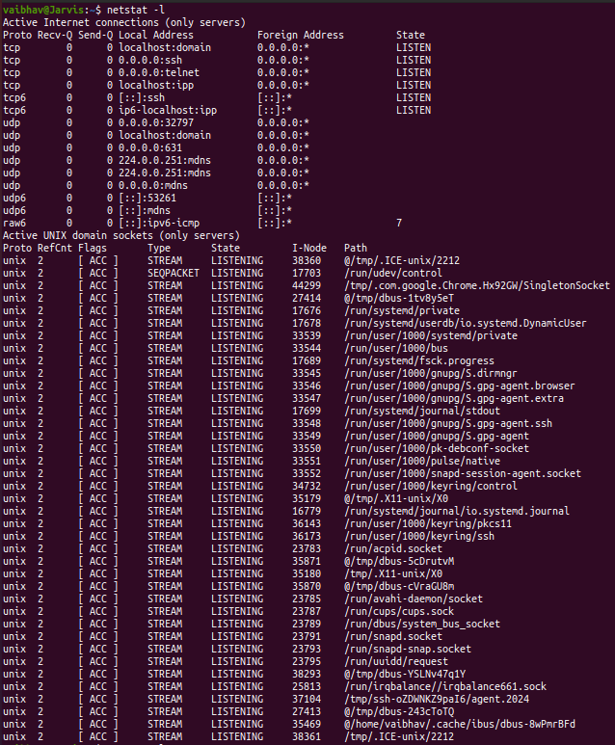

We can use the **netstat** command with **-l** flag which is basically used to list all actively listening ports including both the UDP and the TCP port.

1. **See the mail xchange (MX) record for** [**www.gmail.com**](http://www.gmail.com)

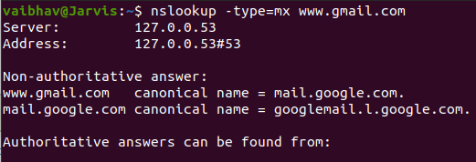

**MX** maps a domain name to a list of mail exchange servers for that domain. All the mail sent to gmail.com should be routed to mail server in that domain

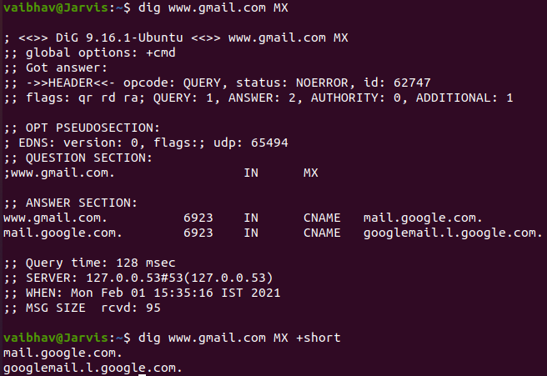

**dig** command can be used with the **MX** option to get the mail xchange records for a site.

**We can use any of the above two methods**

1. **Display the all network interfaces on your machine**



**ip link show** displays the state of all network interfaces on the machi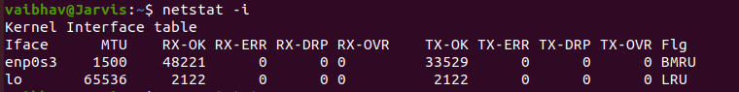**netstat** command with **-i** flag for the interfaces can be used to show all the network interfaces on our machine too

**Any of these can be used**

1. **A list of intermediate routers to reach 8.8.8.8 from your machine, with latency**

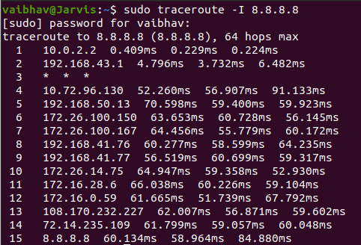

**traceroute** command is used to get a list of all the intermediate routers used to reach 8.8.8.8 along with sudo and **-I** flag which is used to use ICMP ECHO as probe. The latency is given by the round trip time.

1. **Send 10 echo requests to 8.8.8.8 server from your machine**

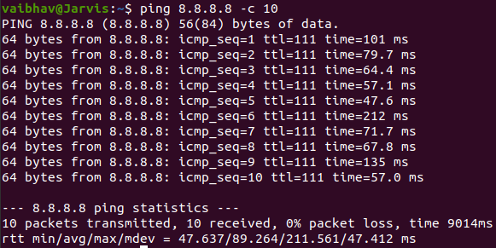

We use the ping command to send echo requests and the number of echo requests can be controlled with **-c** flag which represents the count of the echo requests we want to send.

1. **Get the IP address of www.bits-pilani.ac.in domain.**

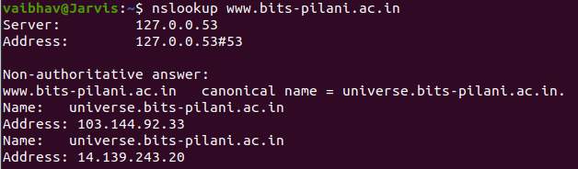

We can get the IP Address using the **nslookup** command along with the name of the site.